Important people of New England Infographic

An infographic is a visual representation of facts or data presented in a quick and clear way.
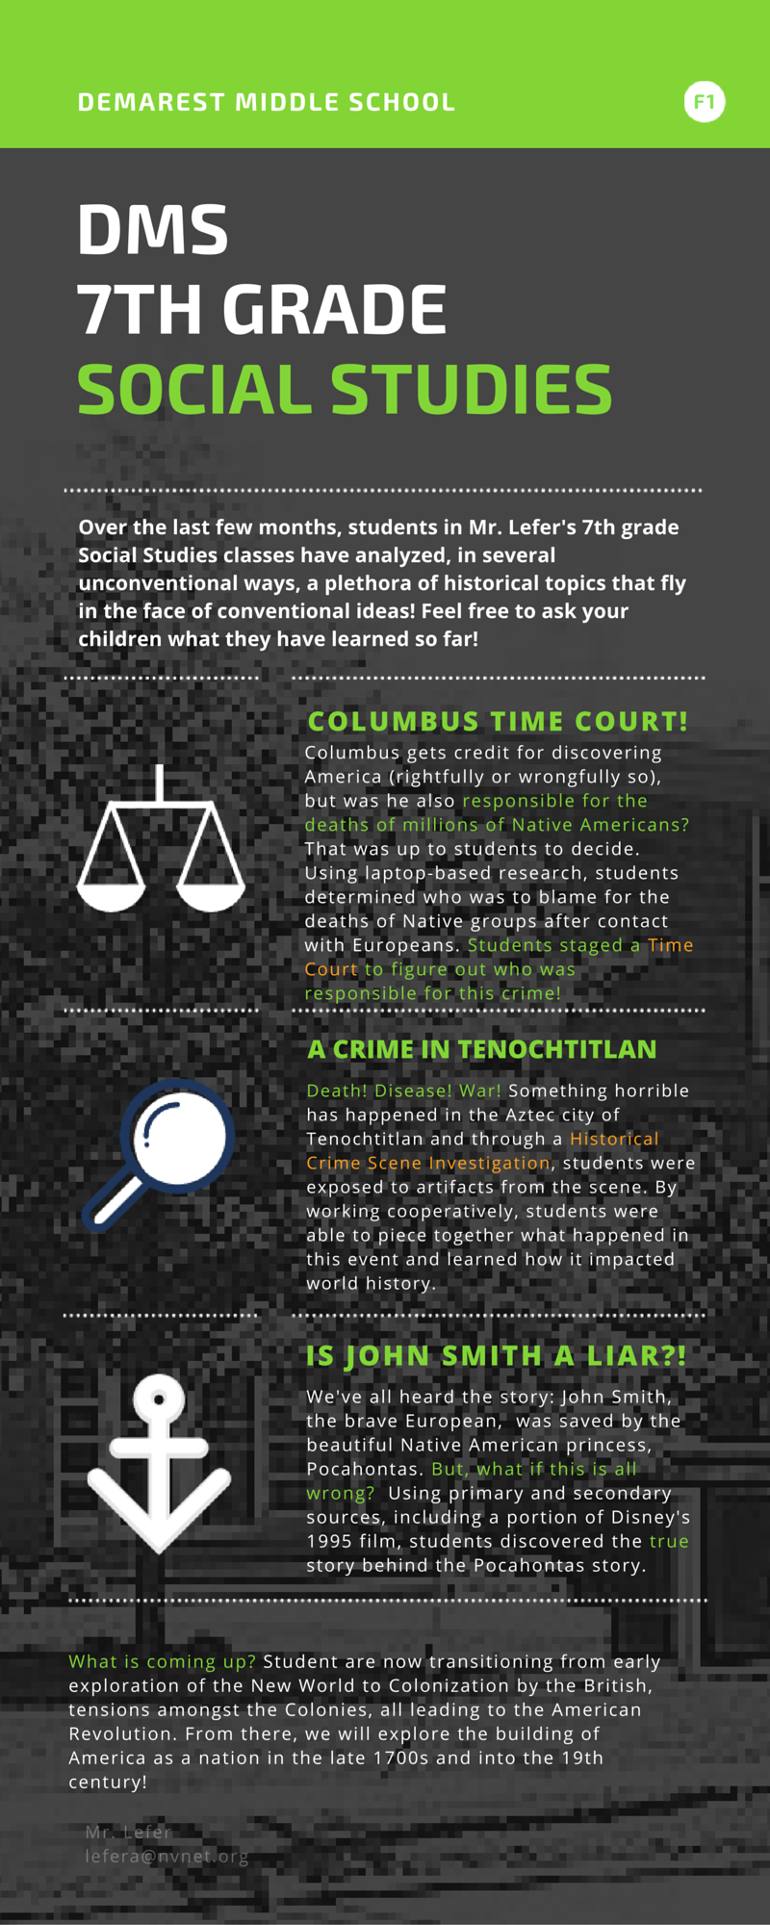
After learning about an important person from the New England colonies, it is now your job to present an infographic to educate others about what you have learned!

Using the reading you analyzed yesterday and information from your textbook, you are to create an infographic to educate others in the class about the important person you were assigned to learn about.

What you need to include:

1. The name of your famous person
2. Any relevant years
3. Major accomplishments and beliefs of your famous person
4. Graphics that are both relevant and eye-catching

How to create your infographic:

1. Go to https://www.canva.com/
2. Create an account- you can sign in with your Google account!
3. Towards the top, you will see “Create a Design”. Then, click “More”.
4. Scroll down to “Blogging and E-books” and click on “Infographics”.
5. Select a design from the left side of the screen.
6. From there, you can edit the text, add images, etc.
7. Have fun!

